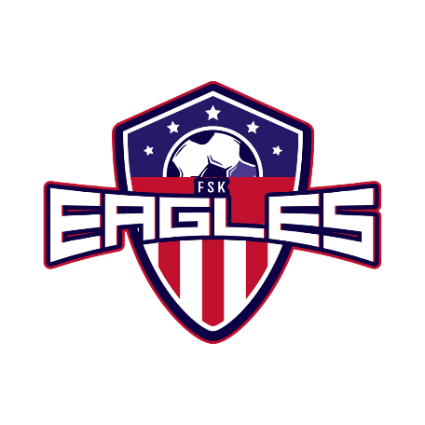
Join Our Winning Team!
Youth Sports Sponsorship Program
Sponsorship Commitment Form
2022 Fall Season

Soccer is the world’s most popular and participated in sport. Perhaps even your own children have played and experienced the love, skill and value of playing this sport. Our goal is to provide a place for each child to learn, love and grow in a fun, challenging and educational environment. Our Youth Sports Sponsorship Program is an avenue for local businesses to make a positive difference in the promotion of recreational soccer in our community. The support received through this sponsorship assists us in keeping our program fees at a nominal level.

In order for us to cover the programs extra costs (scholarships, equipment, awards, field maintenance, etc.), our policy of “nominal cost participation fees” would be greatly affected without your support. Our program strives to teach not only soccer skills, but life skills and life lessons as well. Here are some ways you could help:
- $130.00 ensures a scholarship child can play soccer this season
- $180.00 will buy a set of balls for a team
- $200.00 will buy 1 set of corner flags
- $350.00 will buy 1 set of nets for the goals

We fully realize that you are frequently approached to contribute money for many other worthwhile causes and programs. Please consider helping to keep youth soccer in our community!

Company Recognition and Exposure
Sponsorship provides advertising exposure for your company at our soccer fields.
Additionally, we thank all of our sponsors on our Website & Facebook Page.
Silver Sponsorship = Banner Displayed on light poles at RMP
Gold Sponsorship = Logo on Sleeve of Fall In-House Team Jersey
Platinum Sponsorship= Both Banner and Logo on Sleeve for Fall
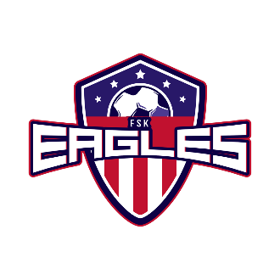
For more information, contact Amanda Carr at fskjreaglessocer@gmail.com!
*To be included on a jersey sleeve, payment needs to be received by June 1st, 2022*

Sponsorship Donation Level
Bronze - $200 Silver - $500 Gold - $750 Platinum - $1000

Other Donation - $__________

Name_____________________________________________ Phone # _________________________

Business Name_________________________________________________________________________

Address__________________________________ City, State, ZIP________________________________
1.Please return the bottom of this sponsorship form with your enclosed check. 2. Please Email camera ready art of your logo for printing to fskjreaglessoccer@gmail.com 3. Make checks payable to FSK Jr Eagles Soccer 4. Mail to FSK Jr Eagles Soccer League PO Box 196 Taneytown MD 21787 or Return to Amanda Carr/Kyle Myers

